**Name – Aniket Jalasakare**

**PRN – 1132210192**

**Roll No - 24**

Connect ec2 linux instance from Windows Instance (RDP) from Putty via accesing Bucket having pem key as a object.

Launch an instance named Linux by selecting quick start as Ubuntu Create a key pair Linux_1 as pem file

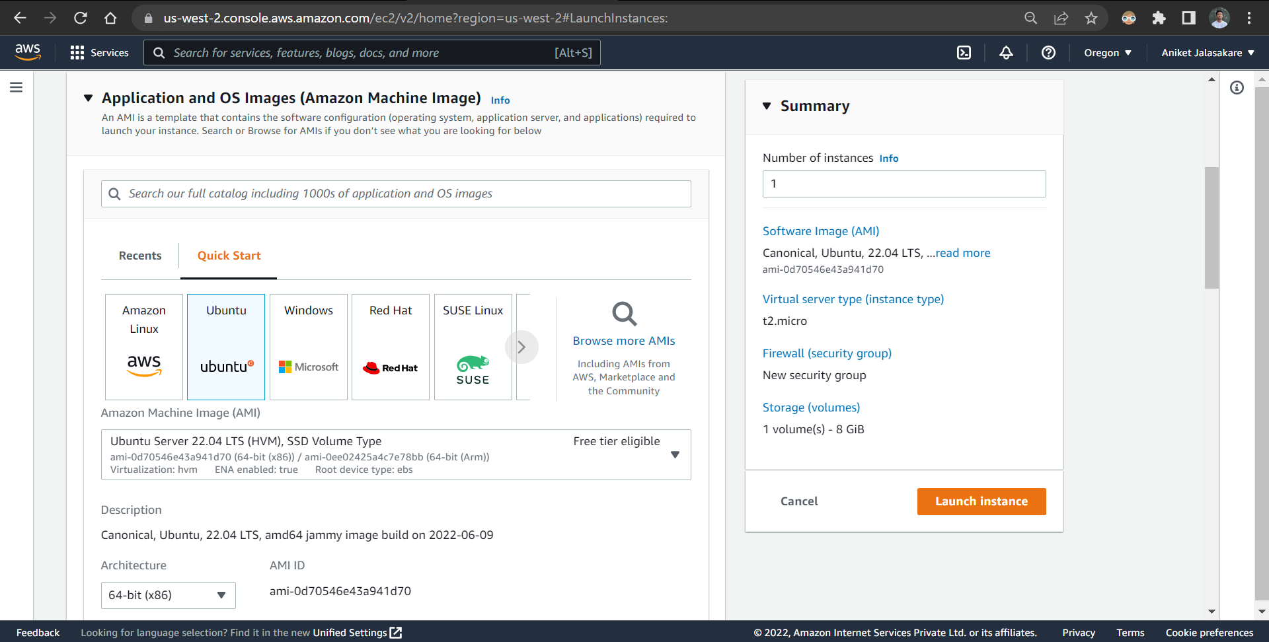

Instance is launched successfully

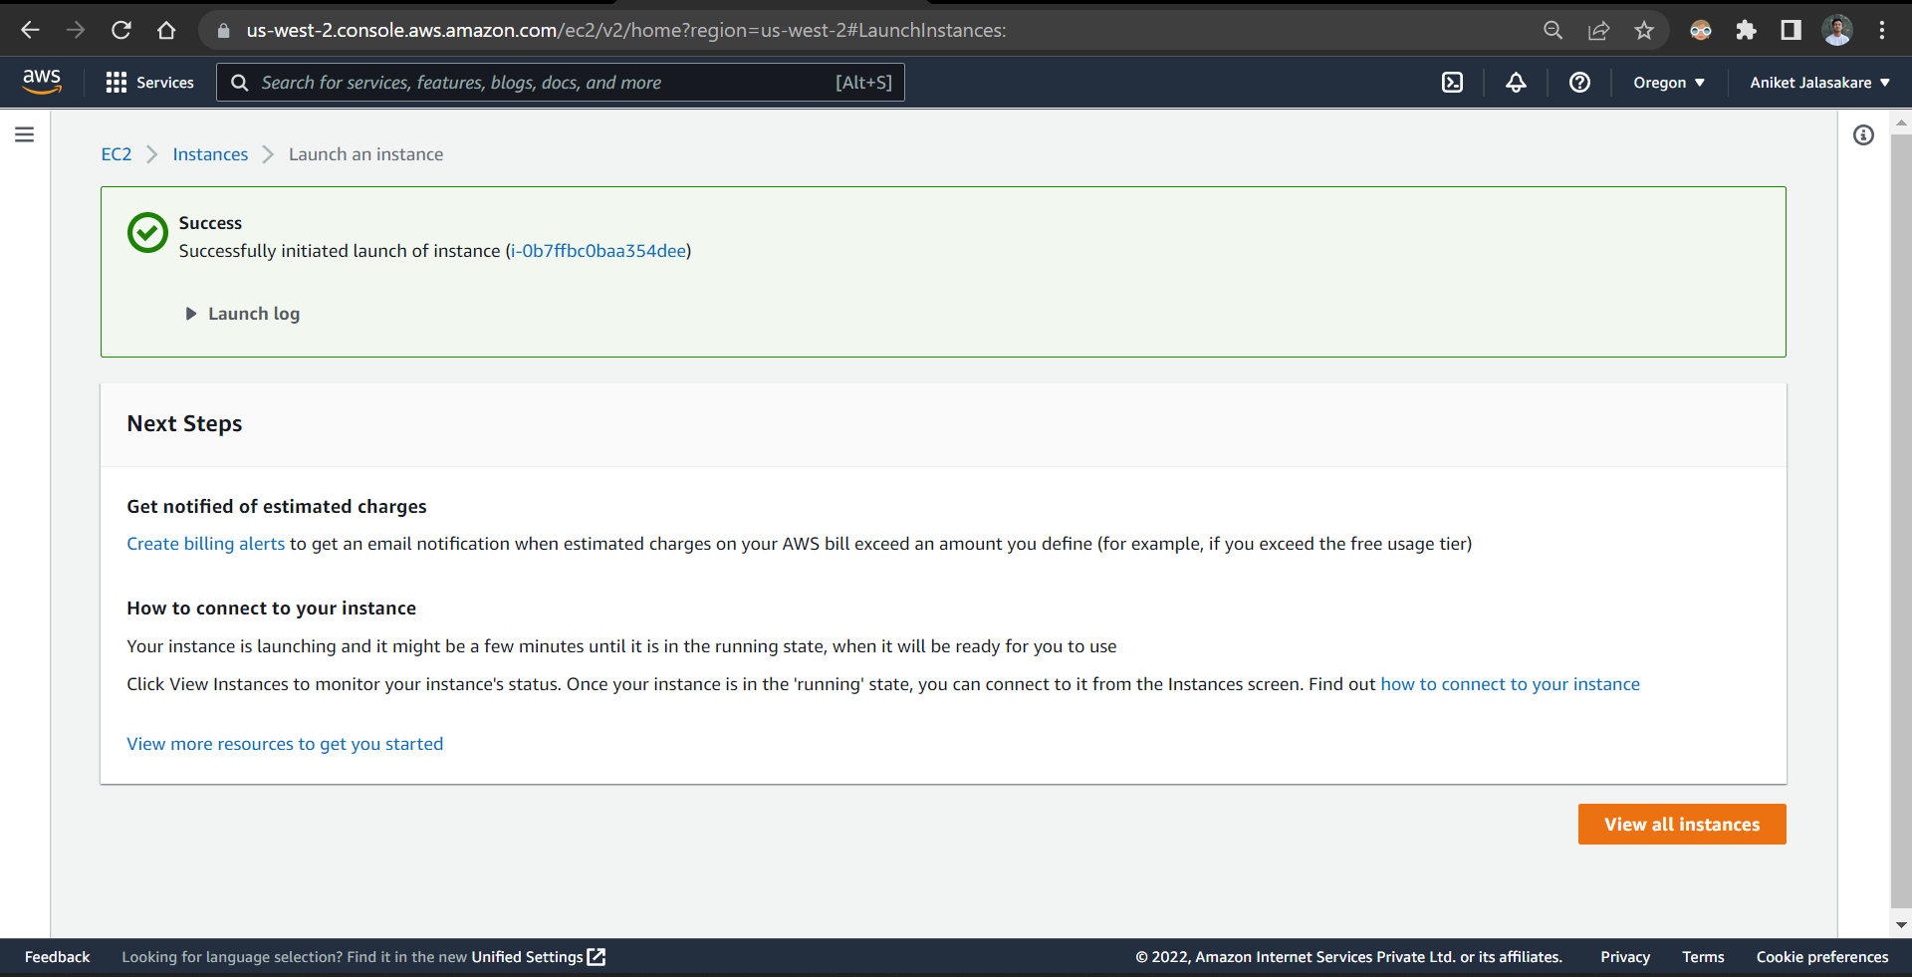

Instance Linux details

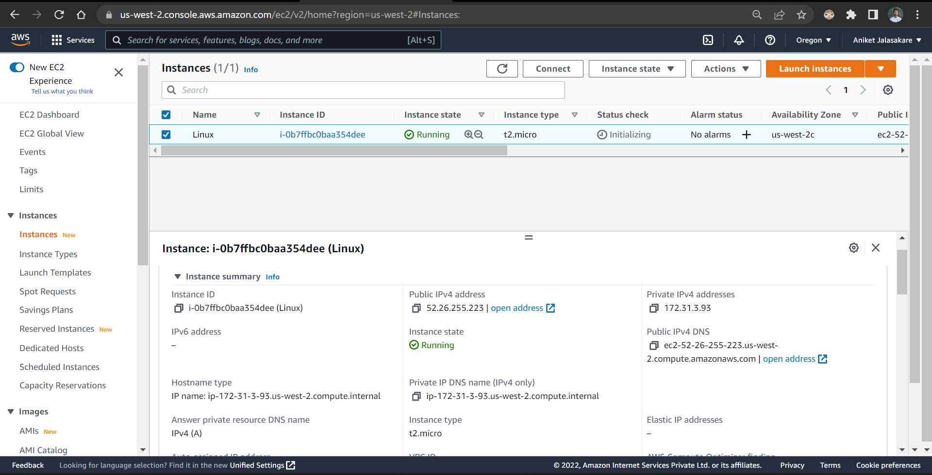

Creating an instance Windows by selecting quick start as windows

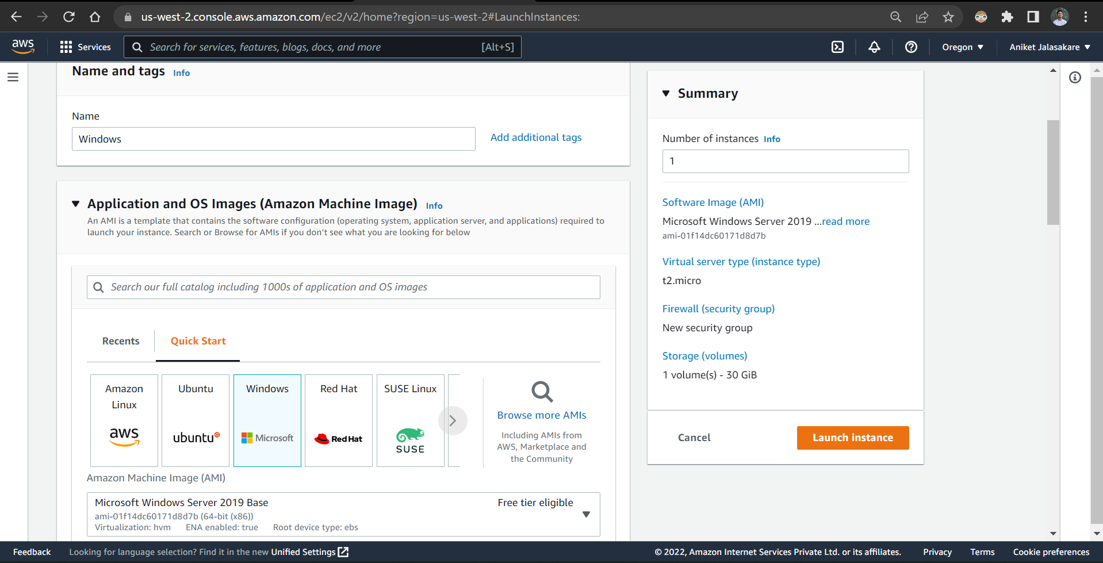

Create a key pair windows_1 as pem file

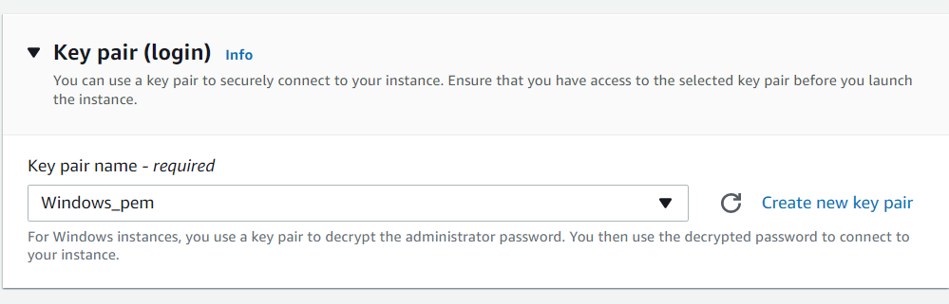

Launch the instance

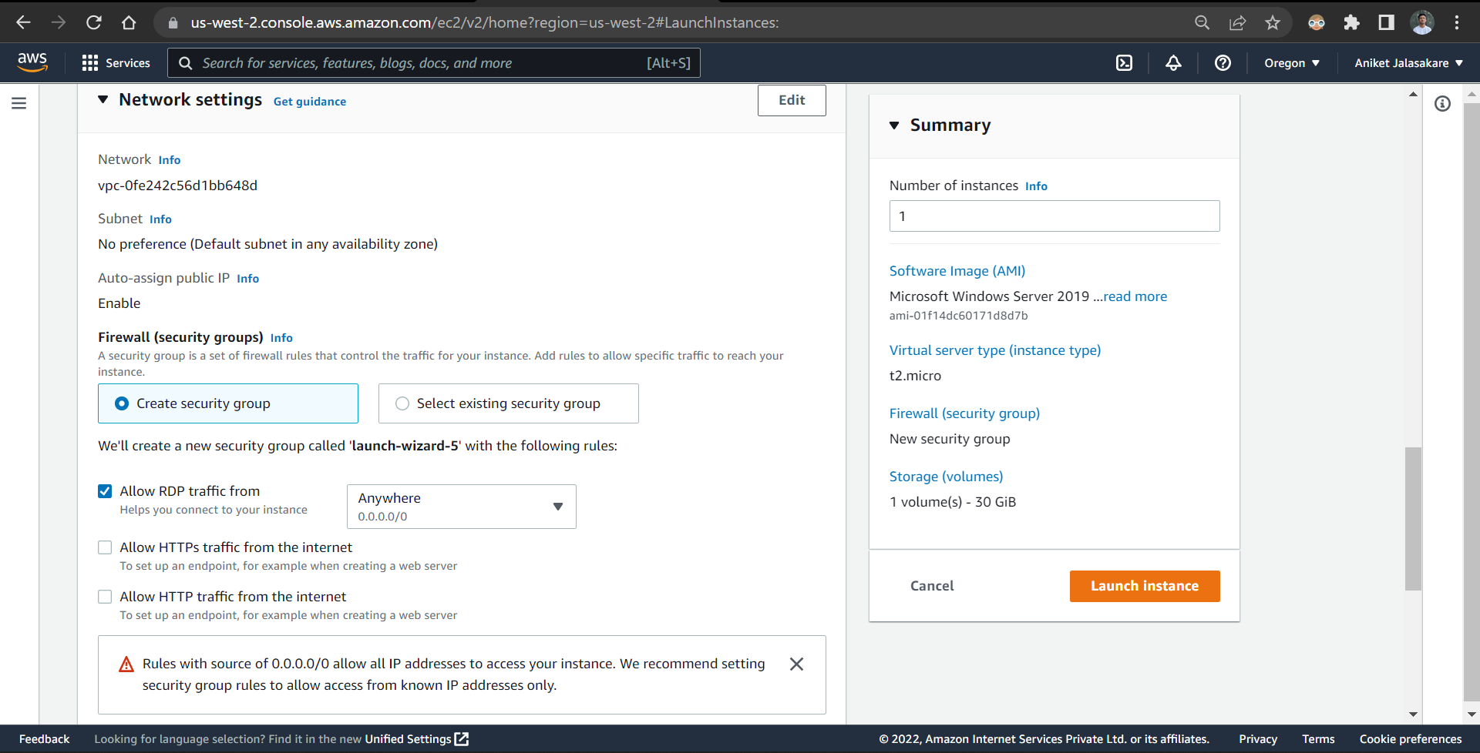

Windows Instance is launched successfully

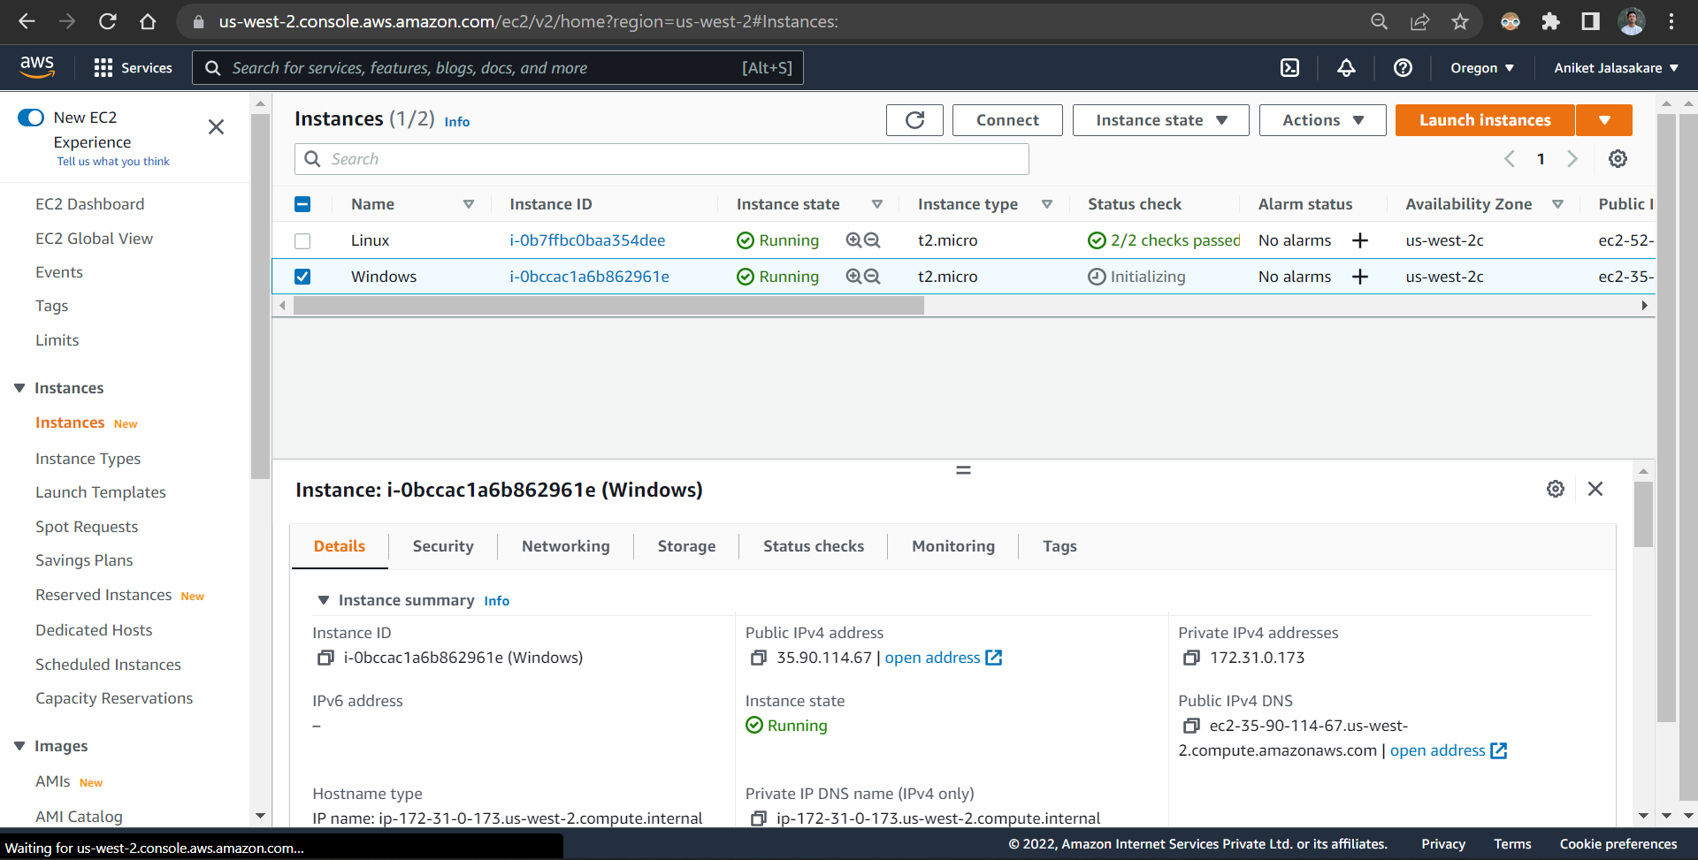

Click on connect and choose the option RDP client, download remote desktop file

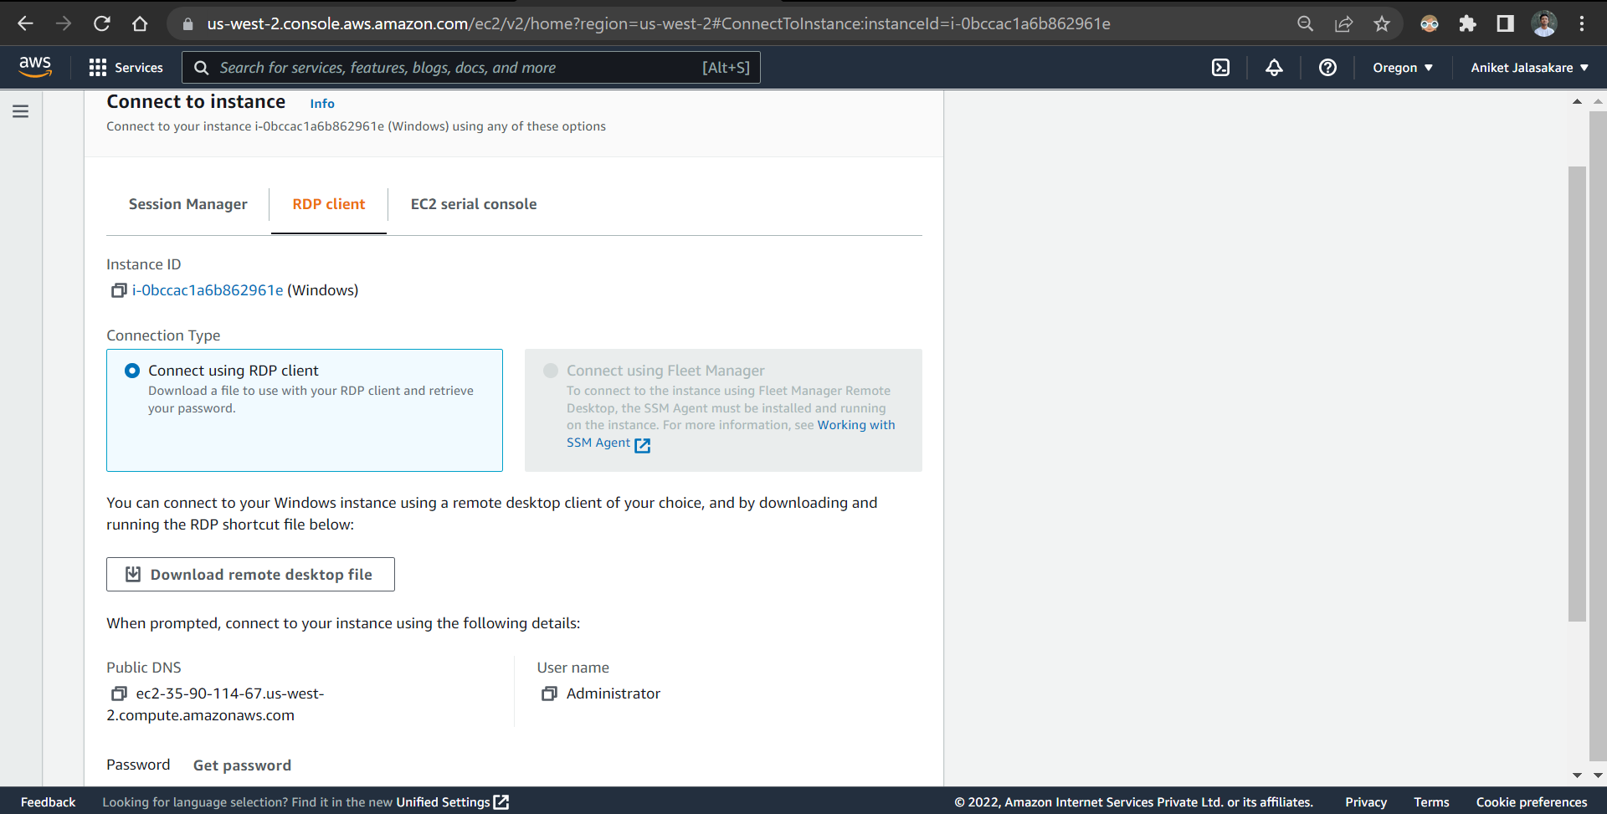

Decrypt password by selecting pem file

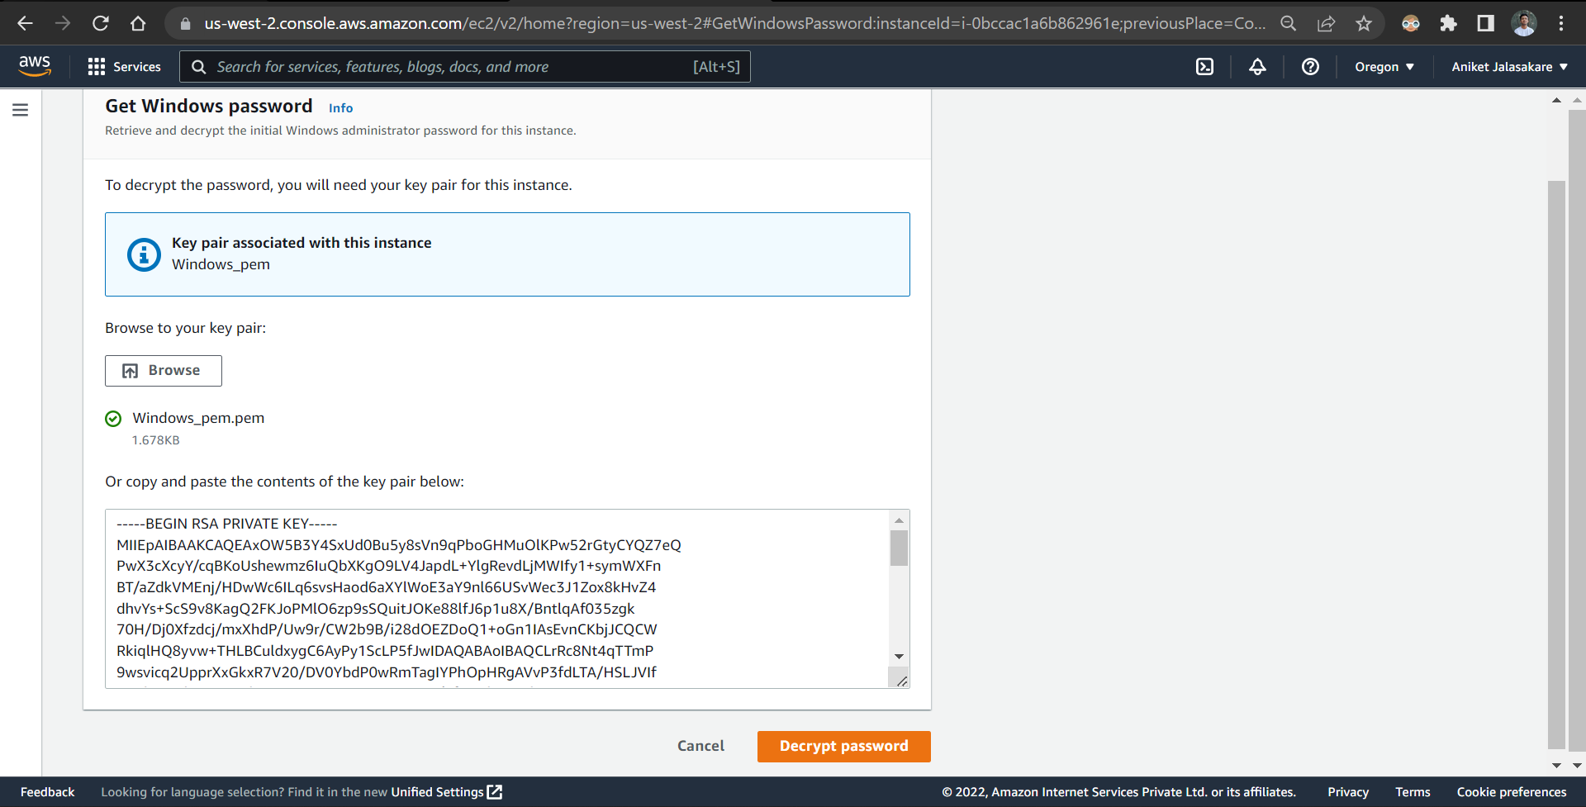

Open RDP file and Login with the valid credentials

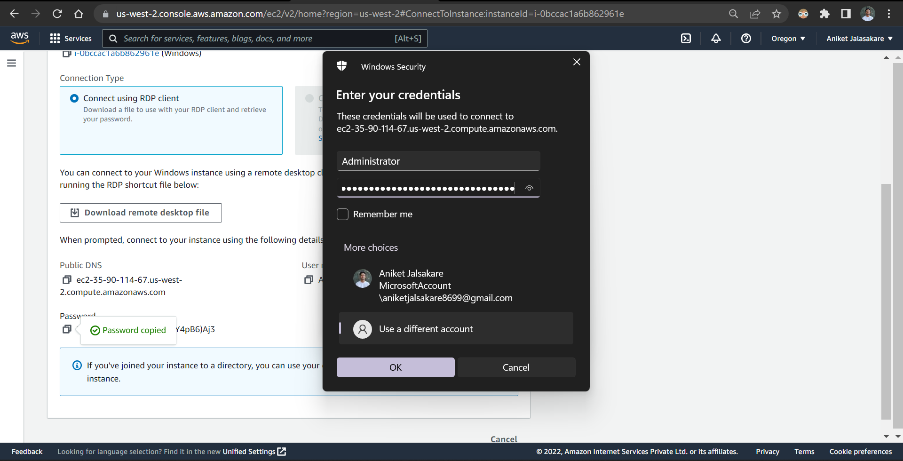

Connect to the remote desktop

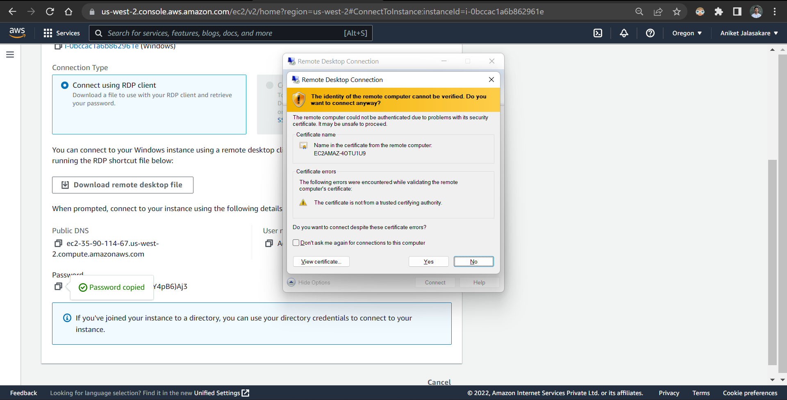

The remote desktop is connected successfully

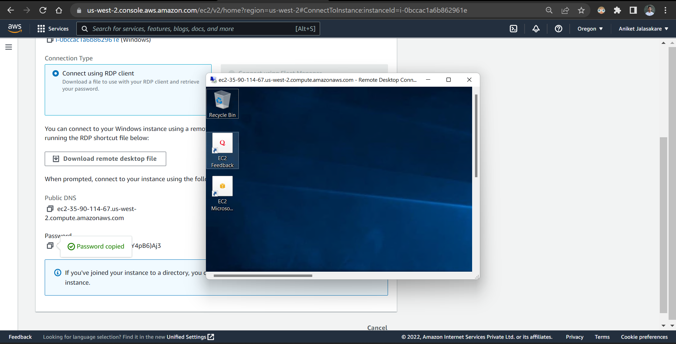

In remote desktop install putty

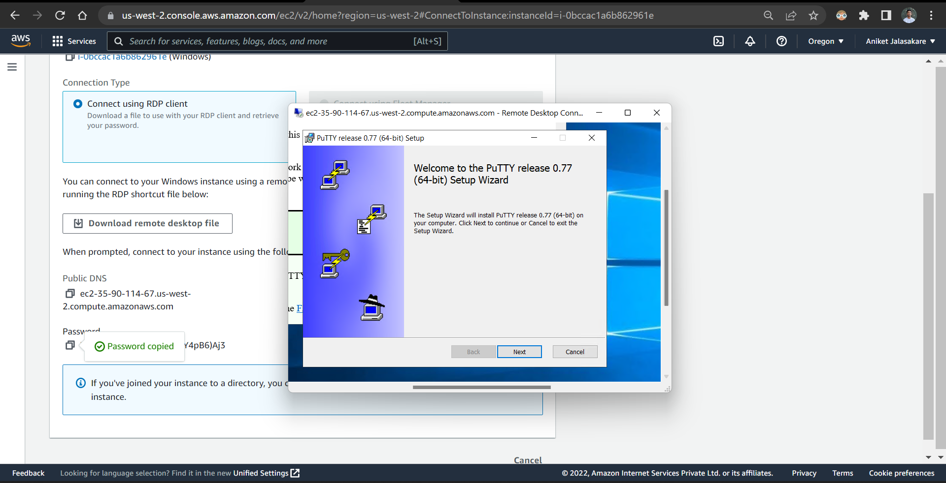

Putty is successfully installed

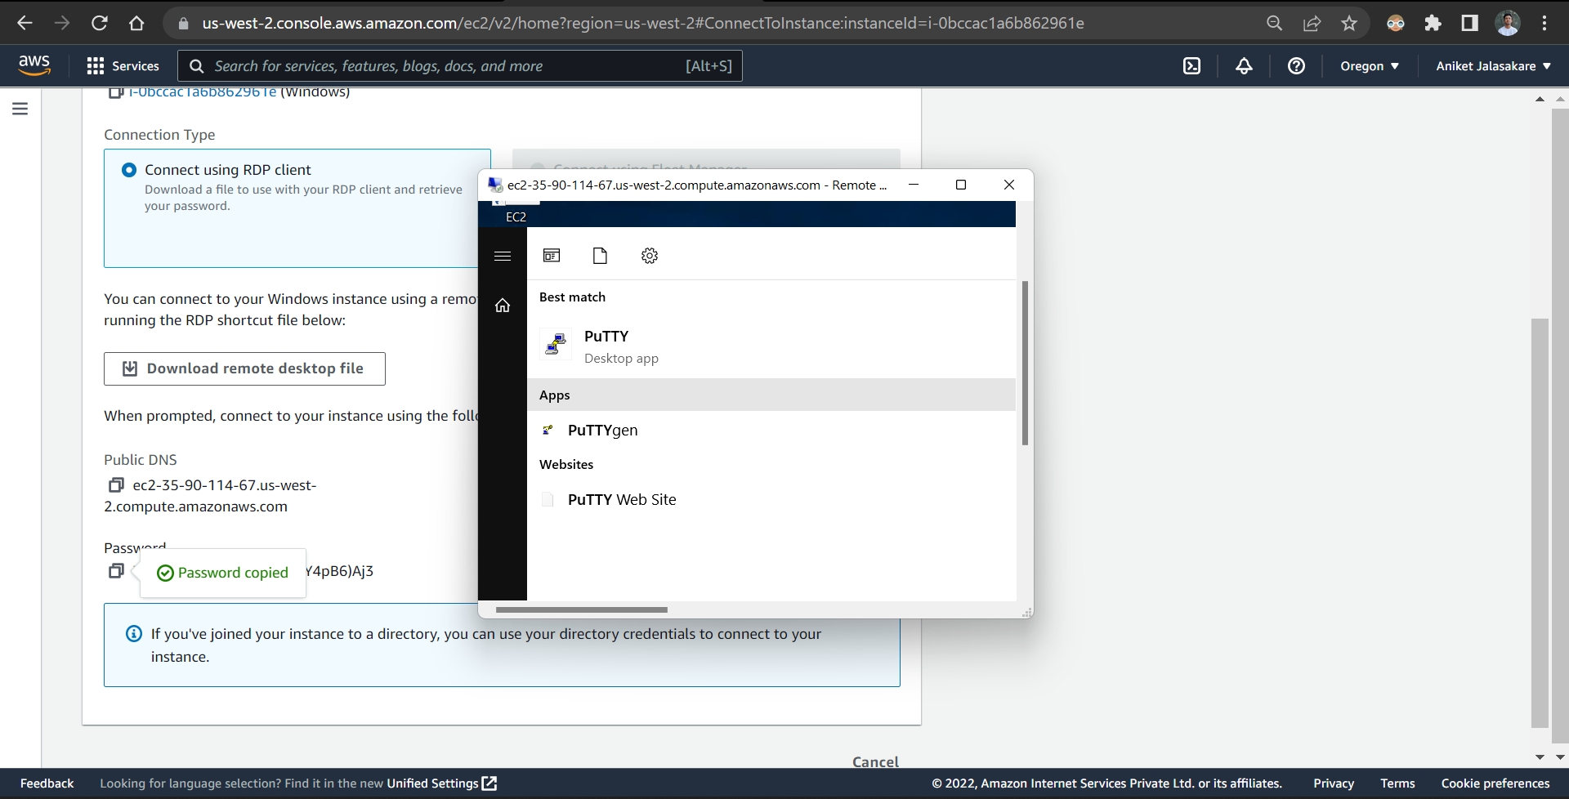

In AWS console create a bucket named ani7600745960

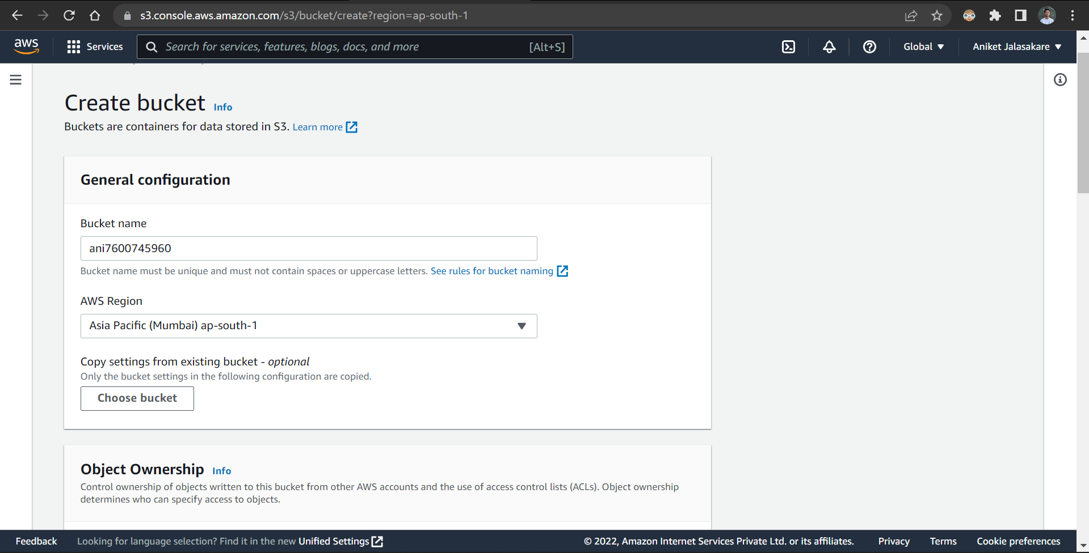

Unblock public access and check the restriction checkbox

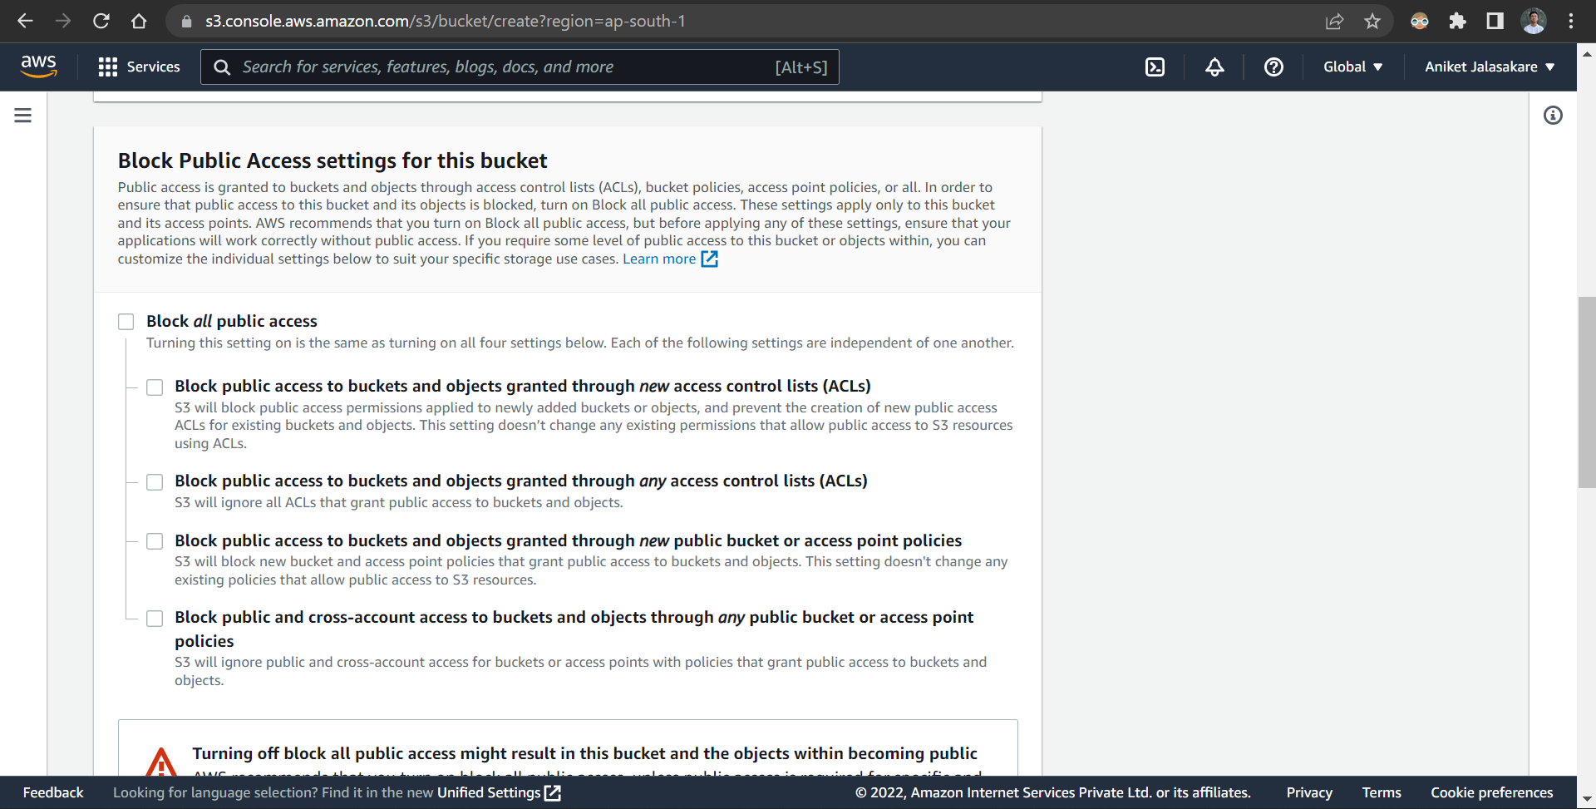

Add tag and create the bucket

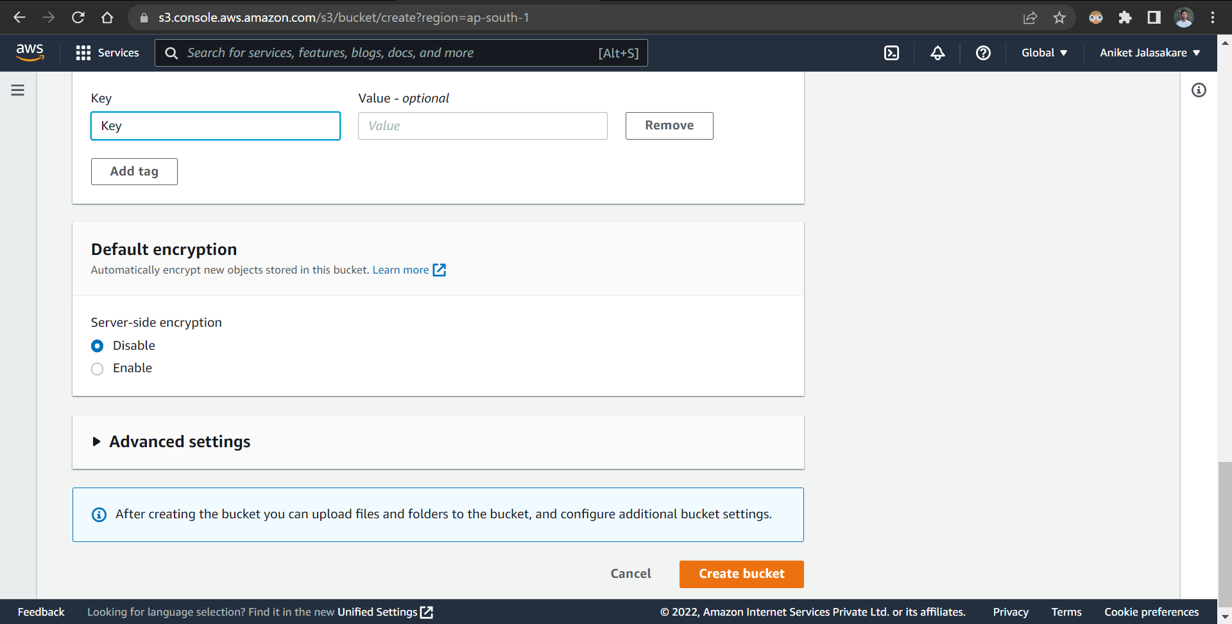

The bucket is created successfully

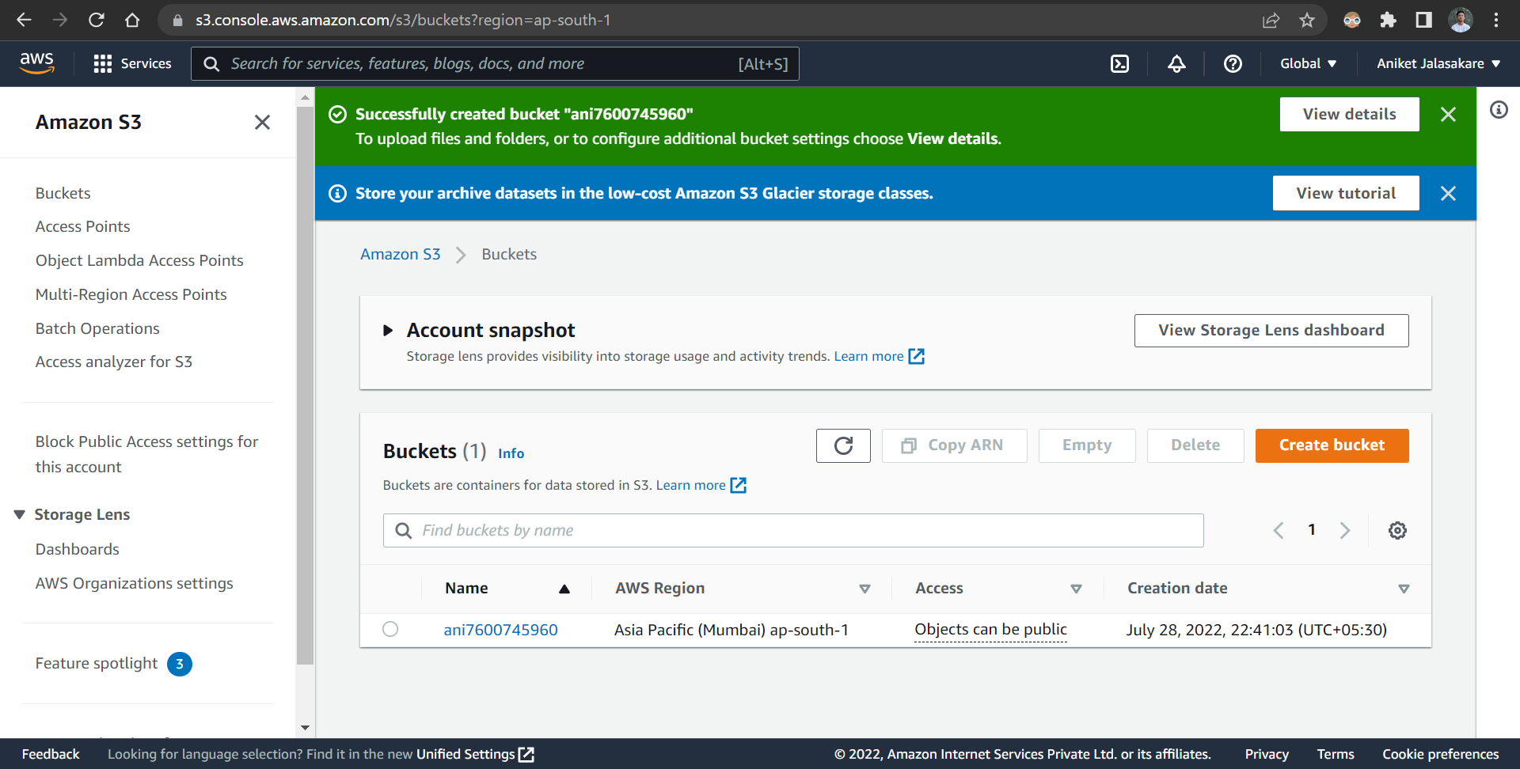

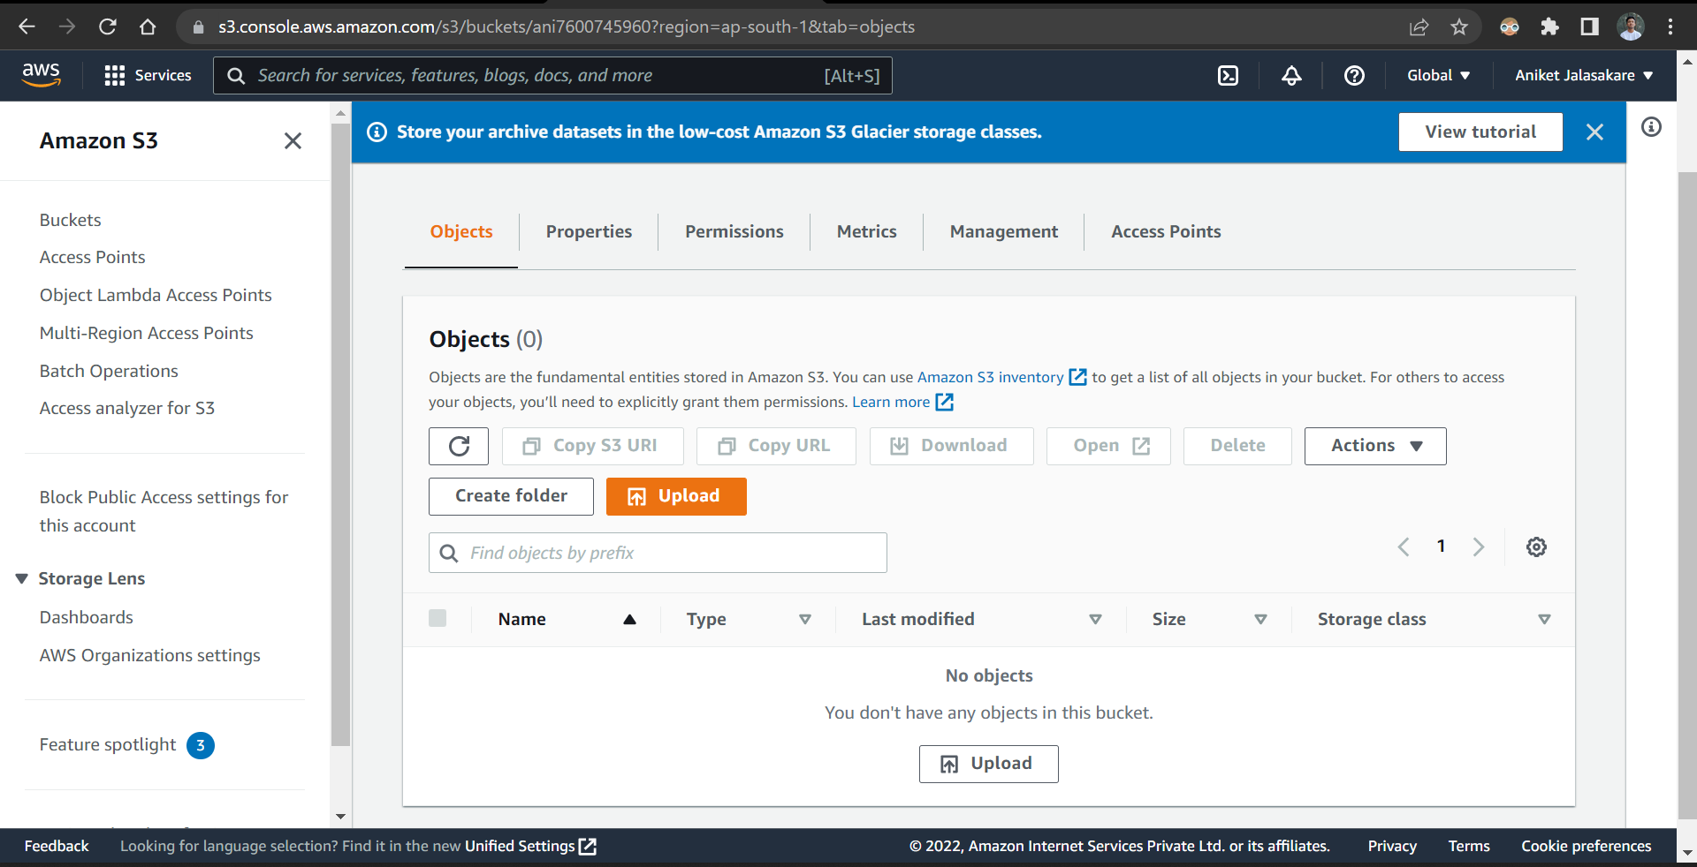

Upload linux pem file in the bucket

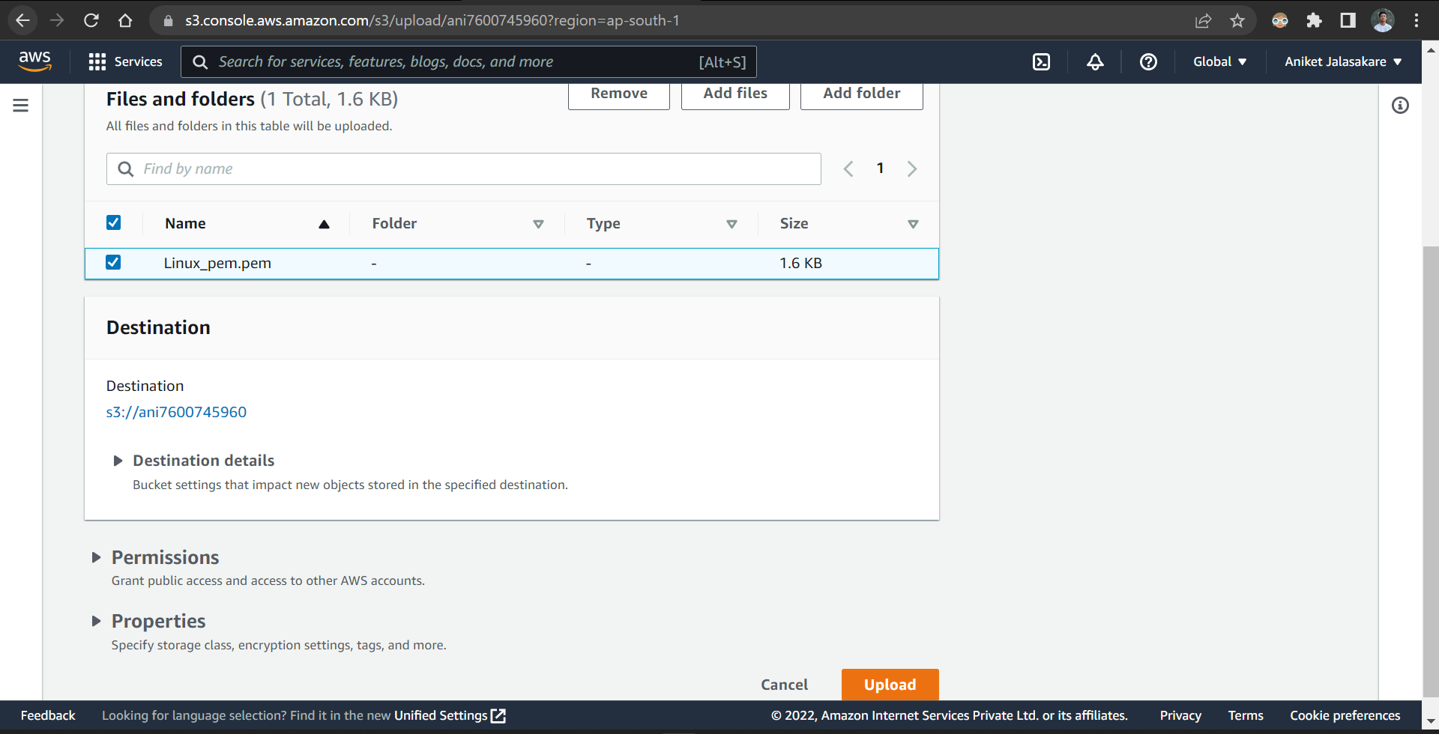

The file is uploaded successfully

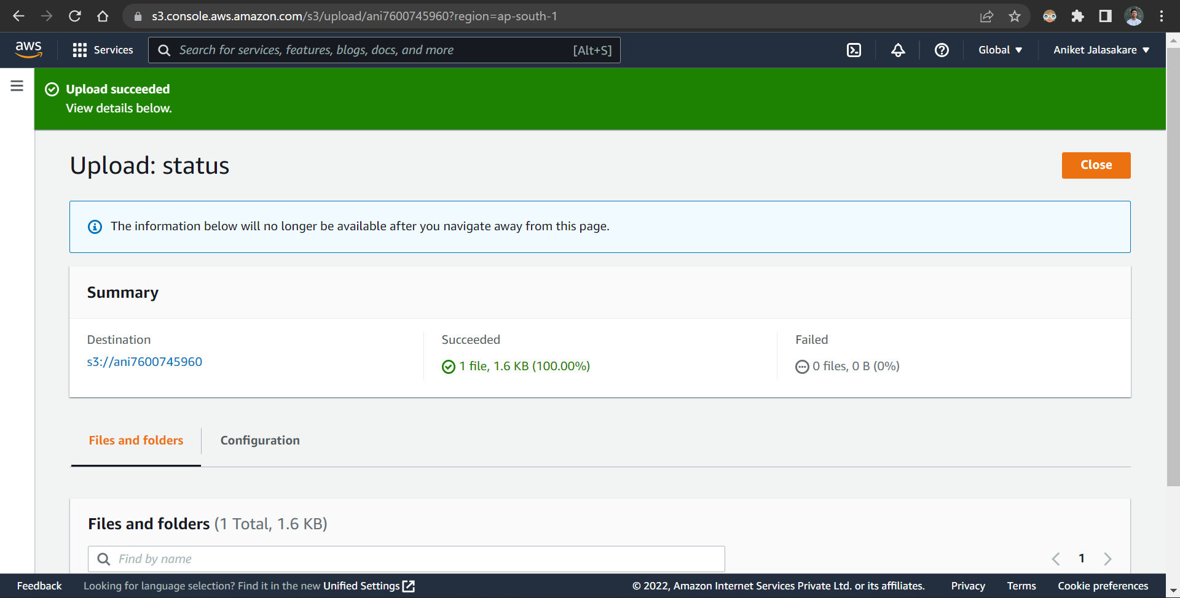

Now, open remote desktop install firefox and login to aws console and download linux pem file into the remote desktop

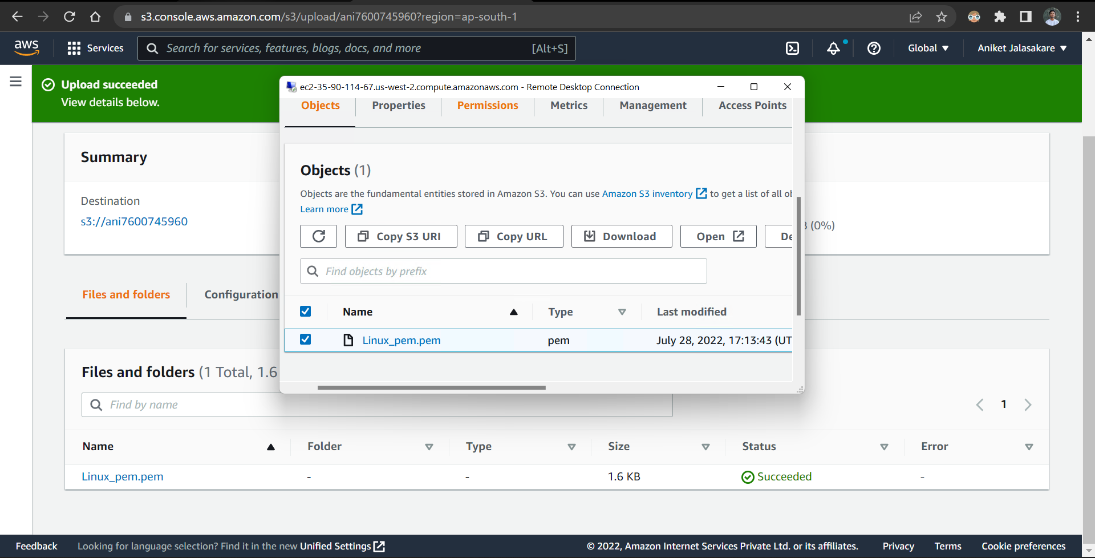

Using puttygen convert linux pem file to linux ppk file

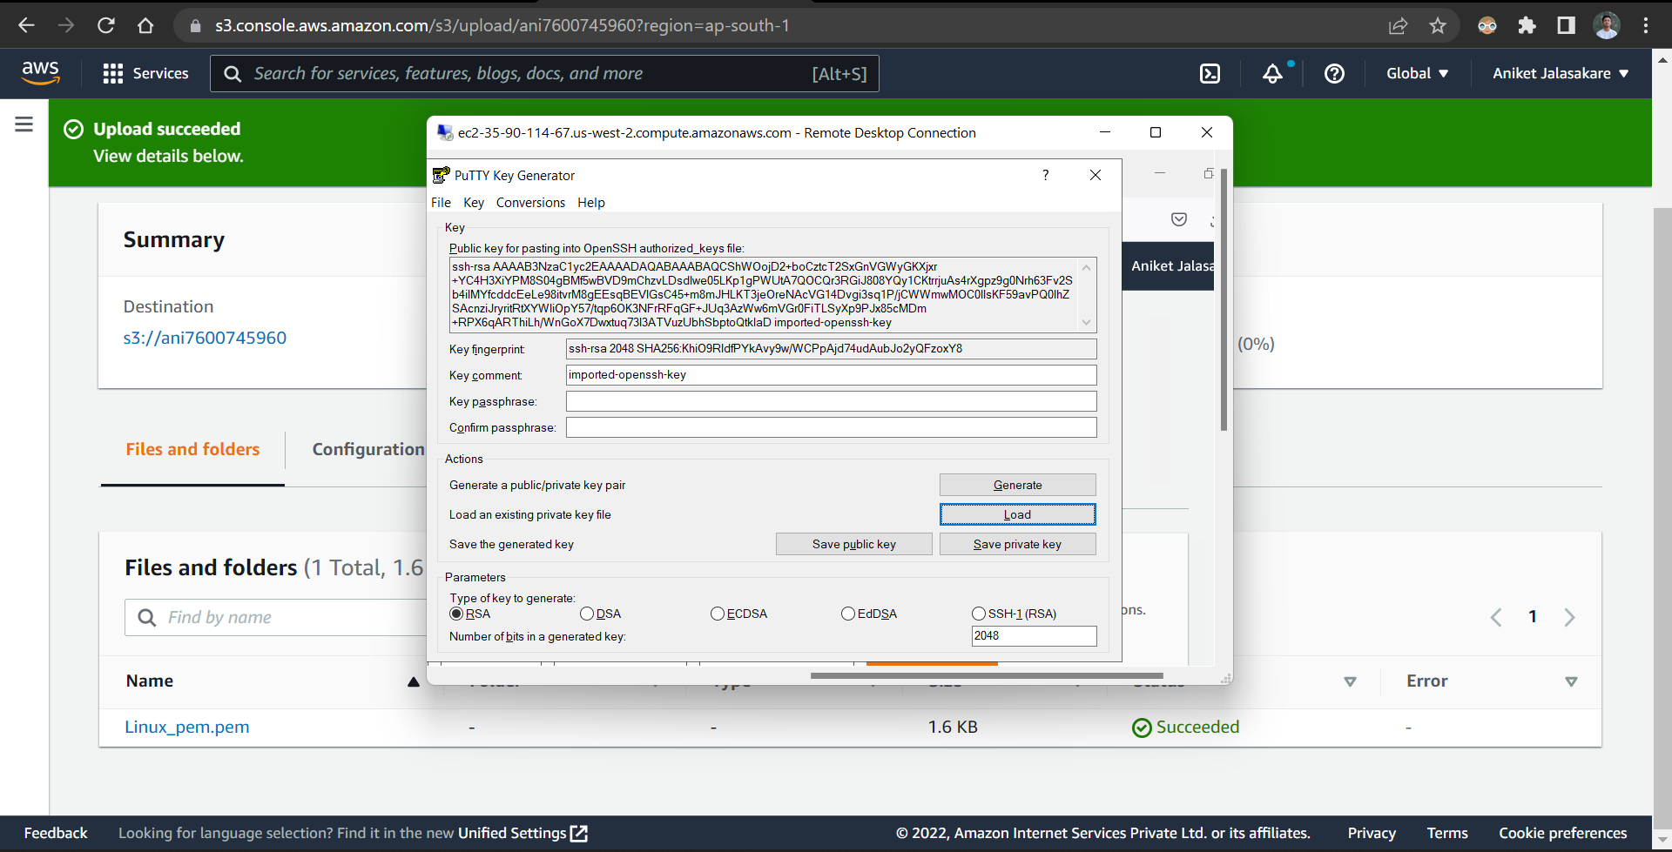

The linux ppk file is successfully generated

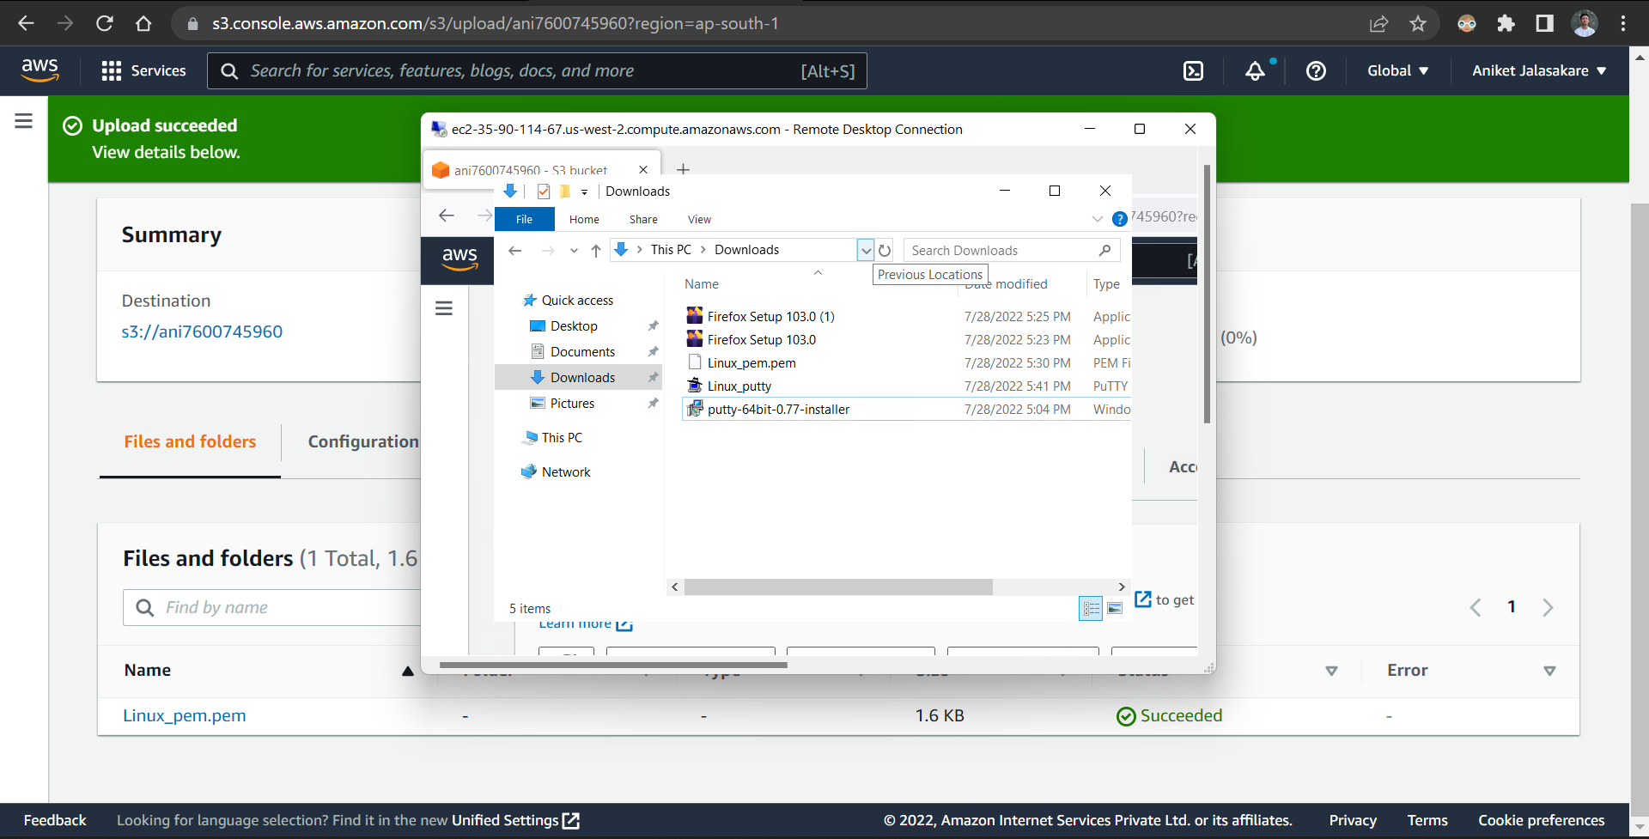

Now open putty in remote desktop, give appropriate hostname

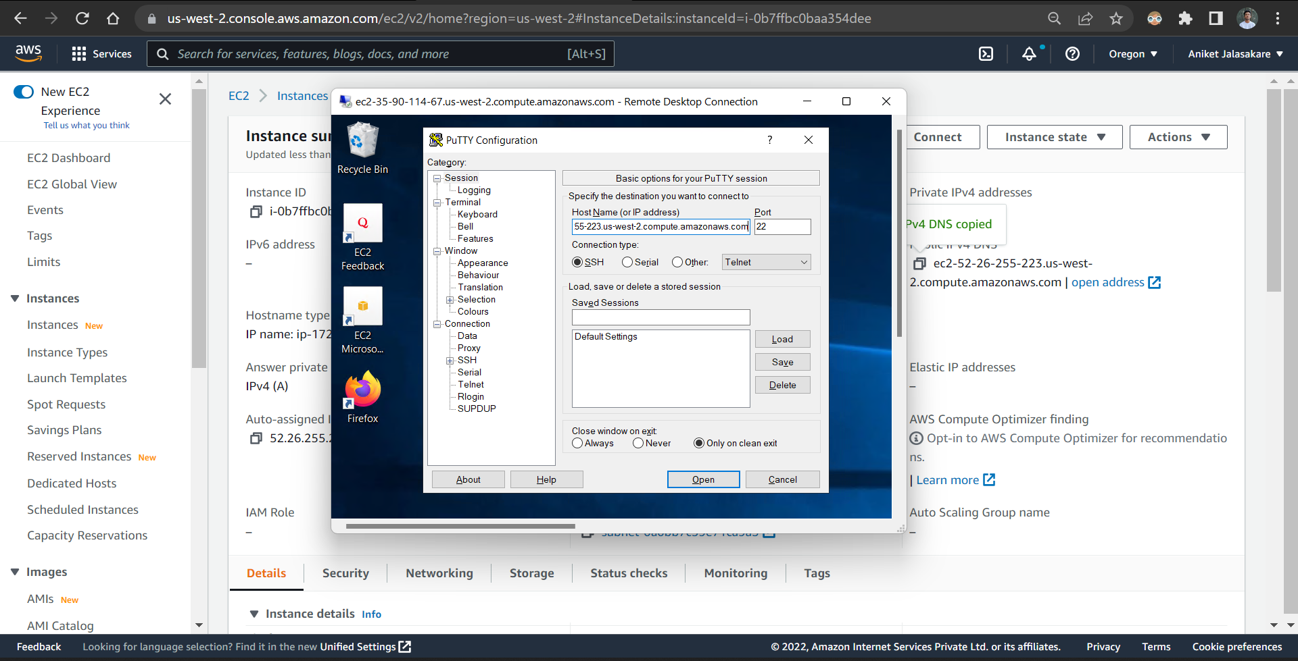

Open data option and give valid username i.e ubuntu

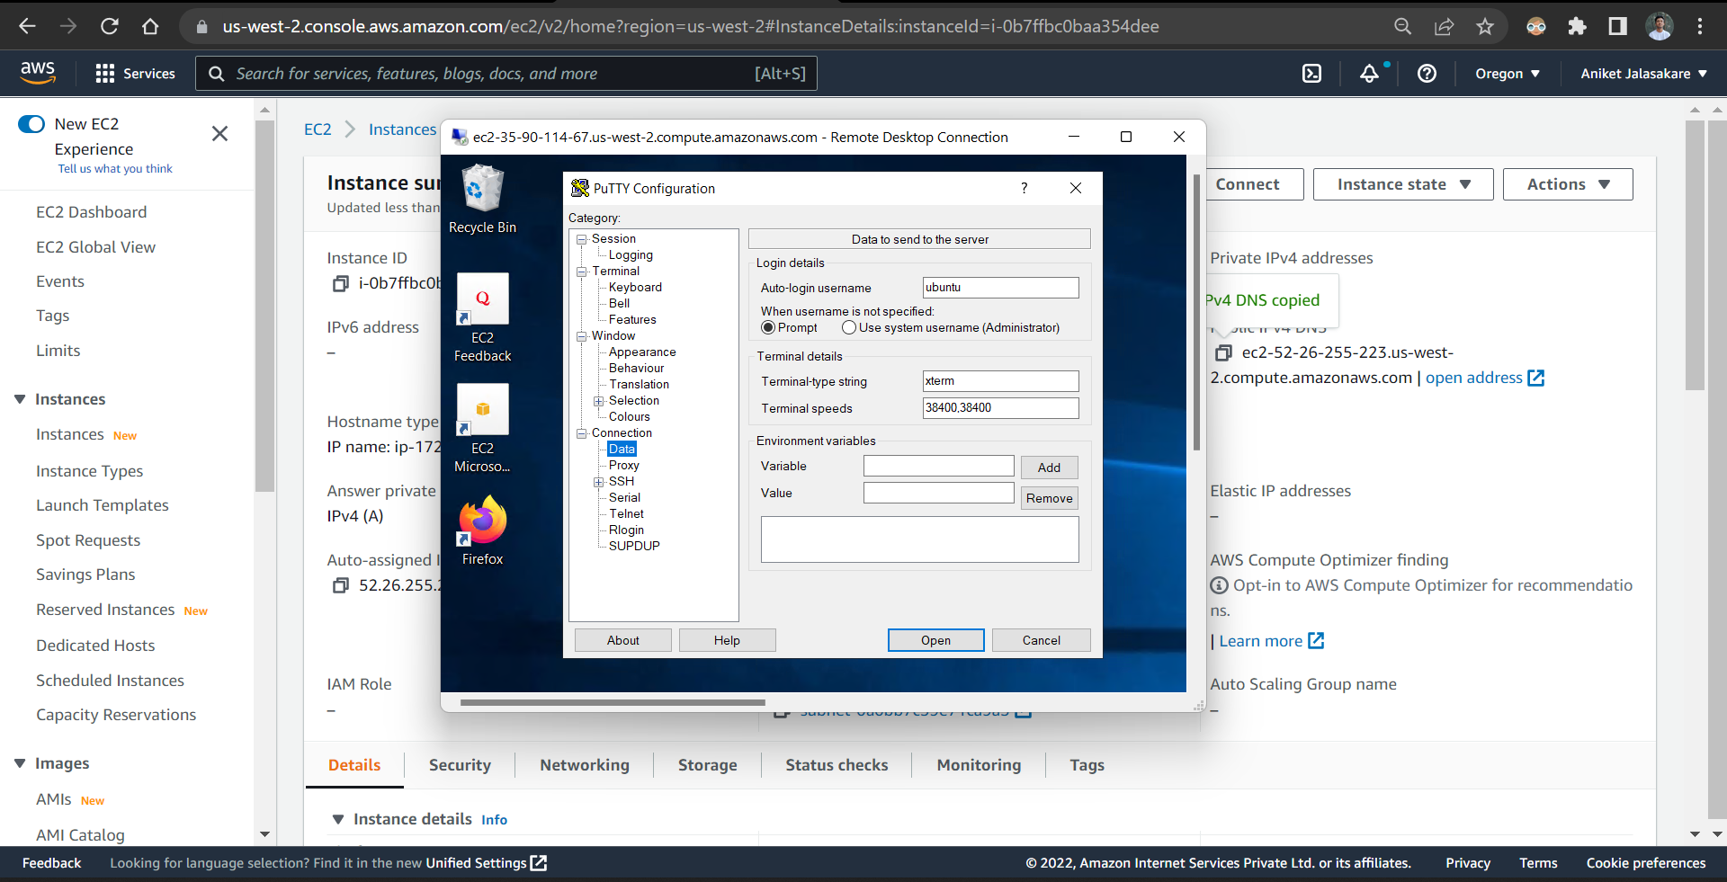

Open auth and browse linux ppk file and connect to the linux terminal

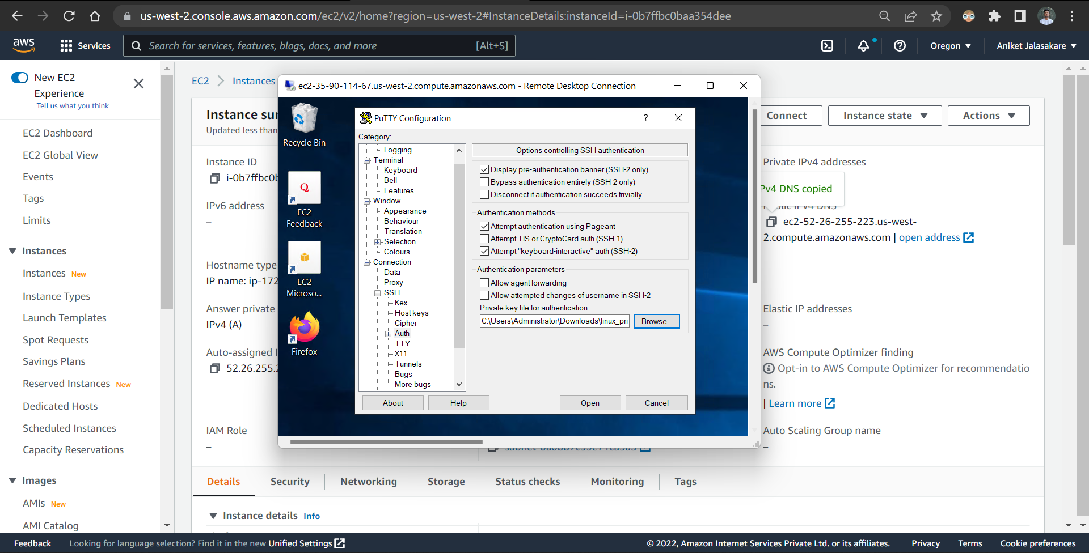

The linux terminal is successfully connected in remote desktop using putty.

